**BUILD AN EMPLOYEE TRAVEL APPROVAL APPLICATION FOR CORPORATES**

**1. INTRODUCTION**

1.1 OVERVIEW

Corporate travel is an integral part of the business world , as companies need to travel to meet clients, attend conferences and meetings, and explore new markets. However, managing employee travel can be a cumbersome task for the HR and travel departments.

1.2 Purpose

The application saves time for both the employee and the travel manager by automating the travel request and approval process. The application ensures that travel request comply with the company’s travel policies, which reduces the risk of non-compliant expenses and unnecessary travel

**2. PROBLEM DEFINITION AND DESING THINKING**

2.1 EMPATHY MAP

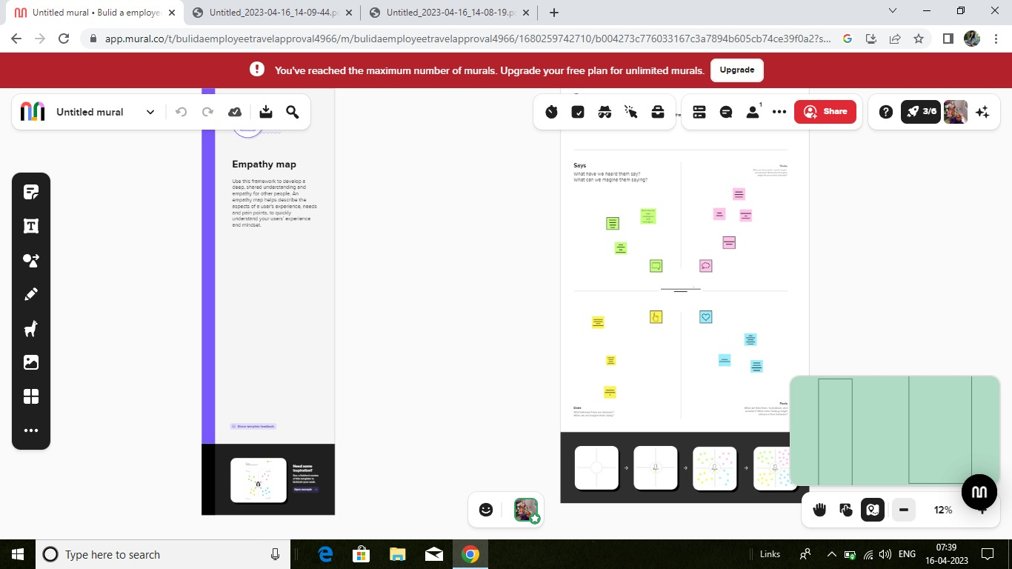

2.2 IDEATION AND BRAINSTORMING MAP

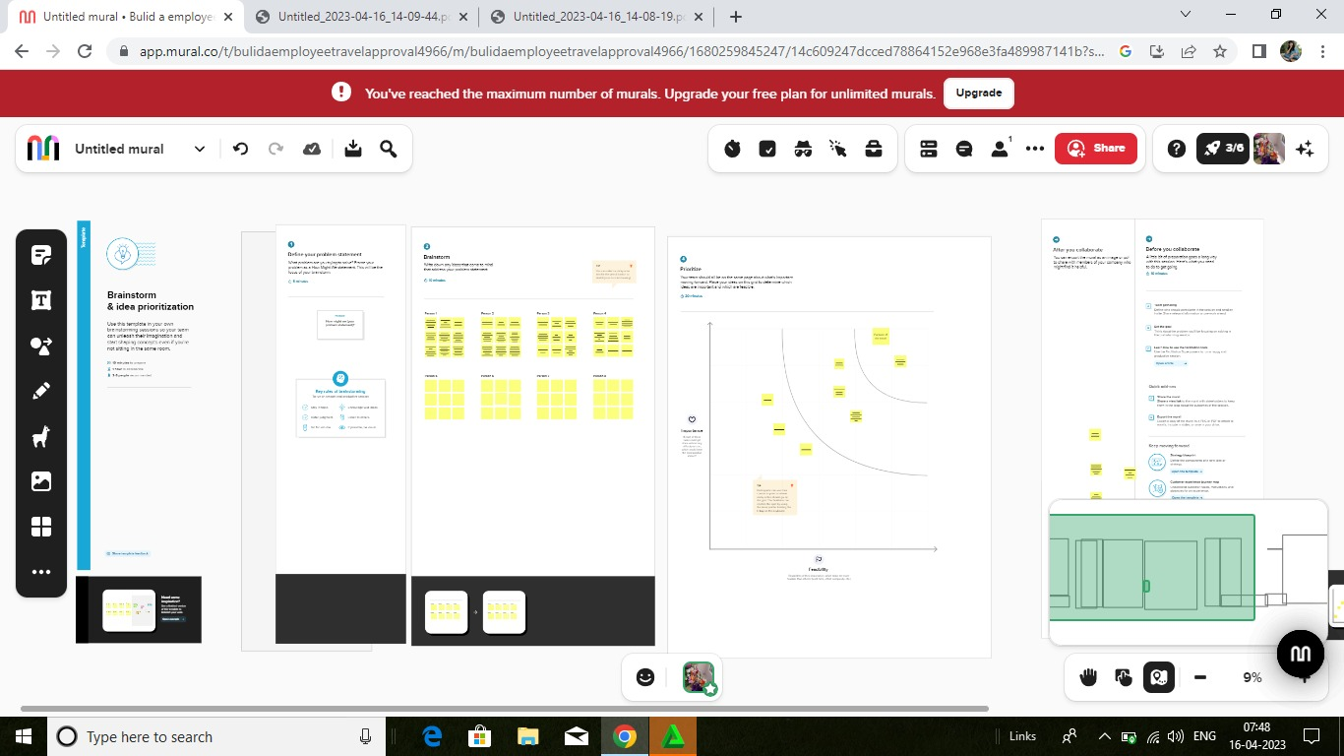

**3. RESULT**

3.1 DATA MODEL

|  |  |
| --- | --- |
| Object name | Fields in the object |
| Department | |  |  | | --- | --- | | Field label | Data type | | Days Remaining | Text | |
| Travel Approval | |  |  | | --- | --- | | Field label | Data type | | Total Expenses | Roll- up summary | |
| Expense Item | |  |  | | --- | --- | | Field label | Data type | | Status Indicator | Picklist | |

3.2 ACTIVITY AND SCREENSHOT

Activity-1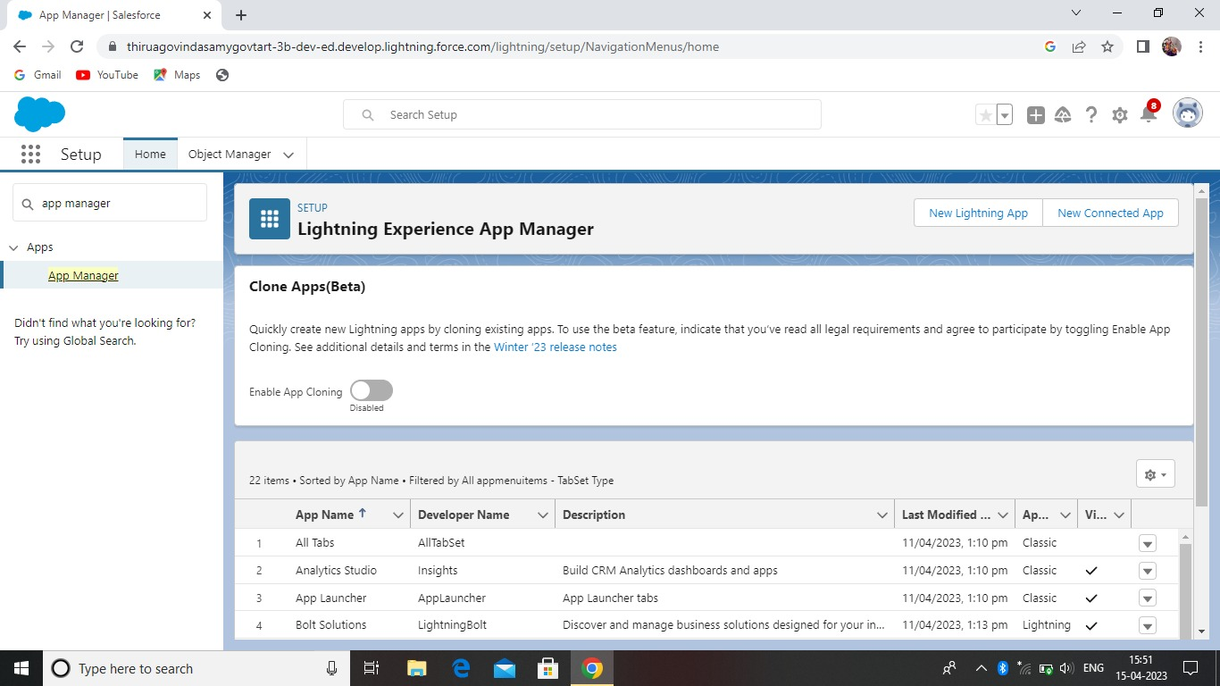

Custom object creation

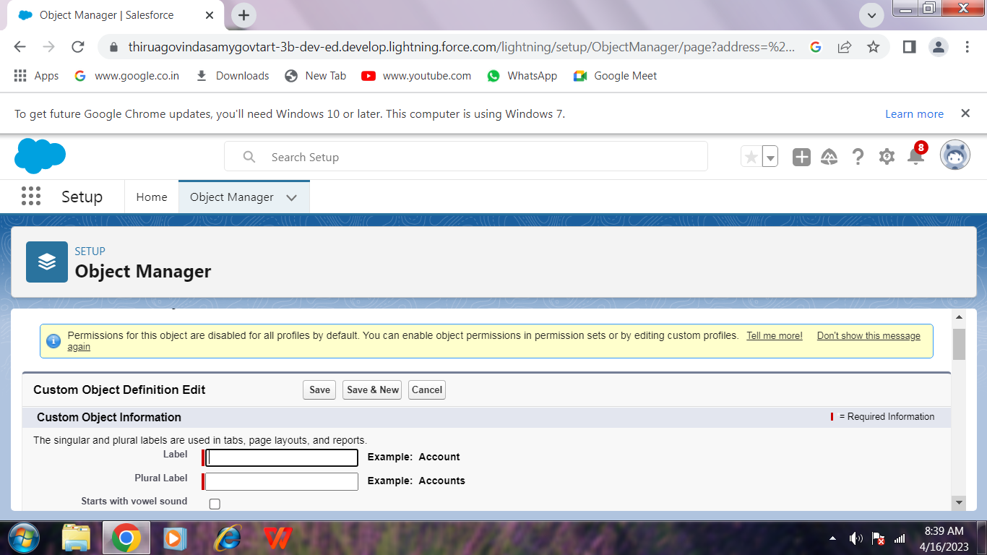

Department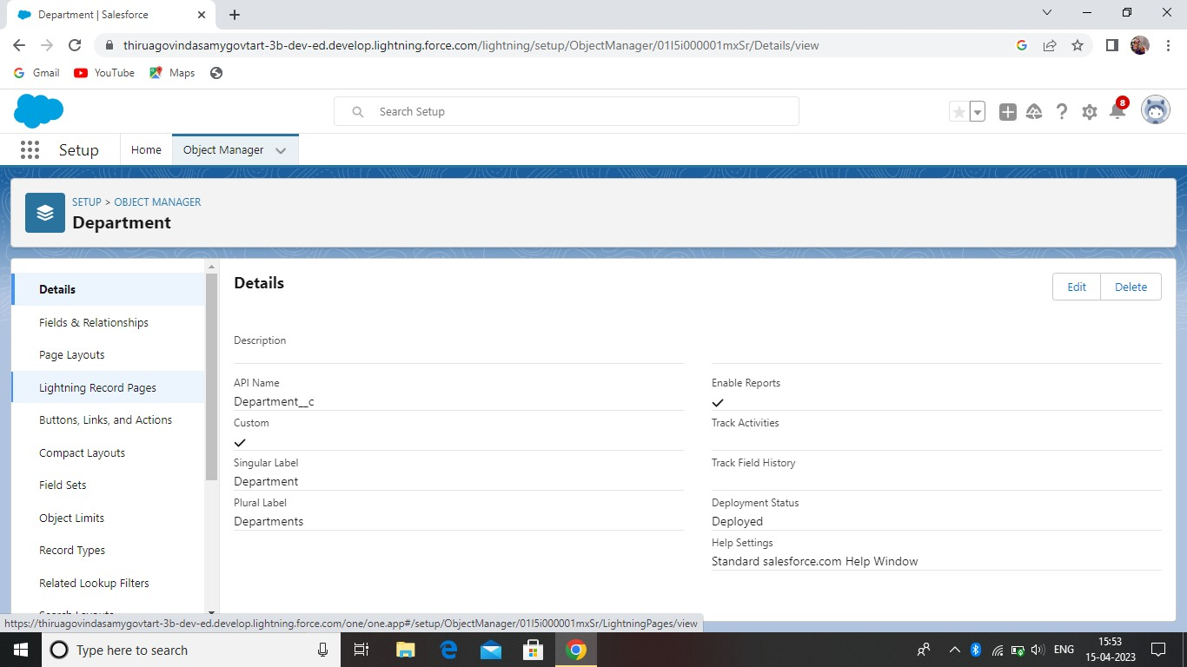

Travel Approval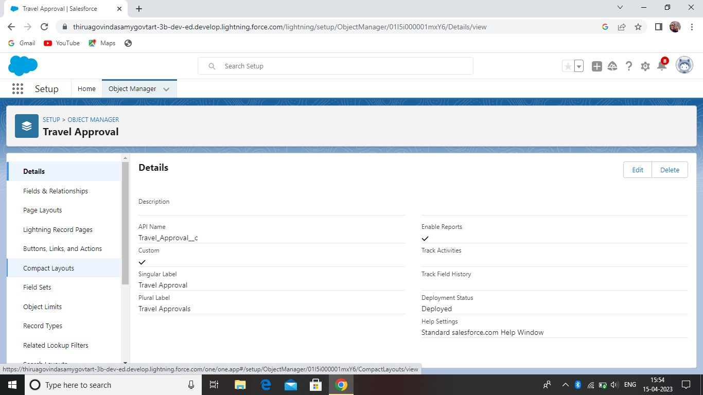

Expense Item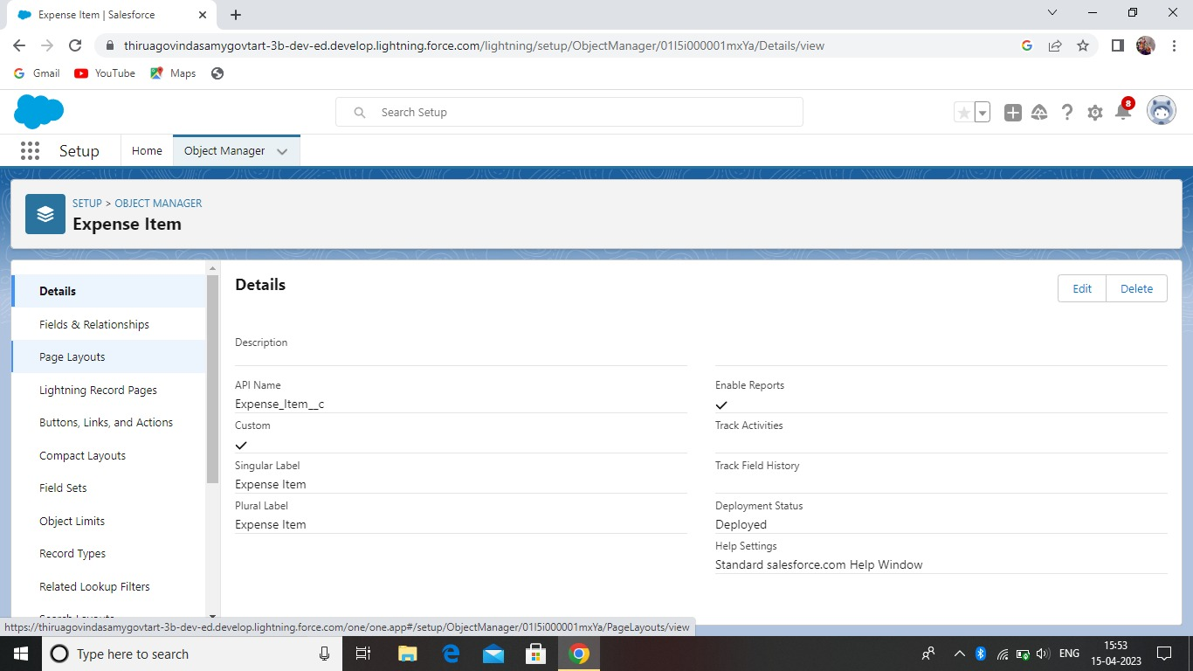

Tabs

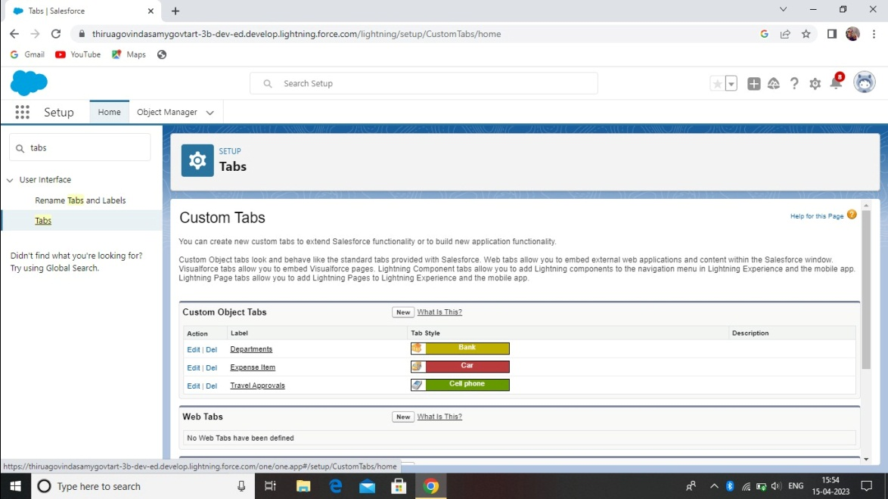

Fields and Relationships

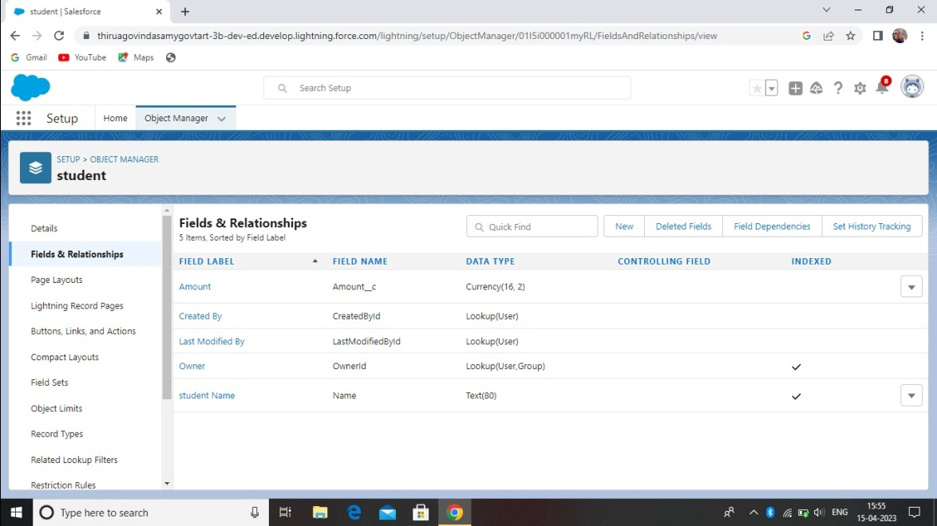

Import Department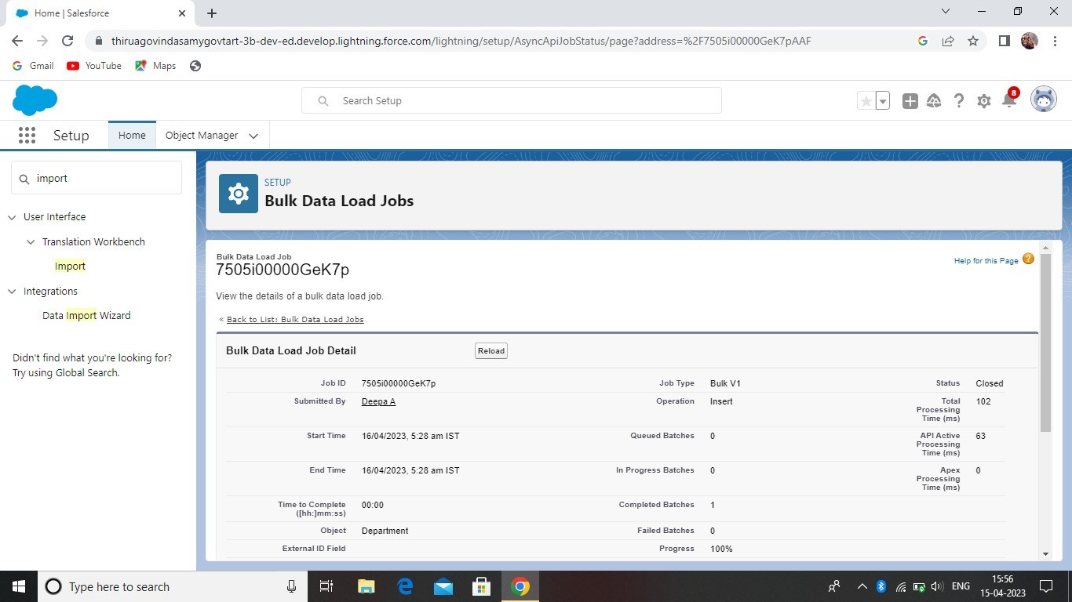Customize User Interface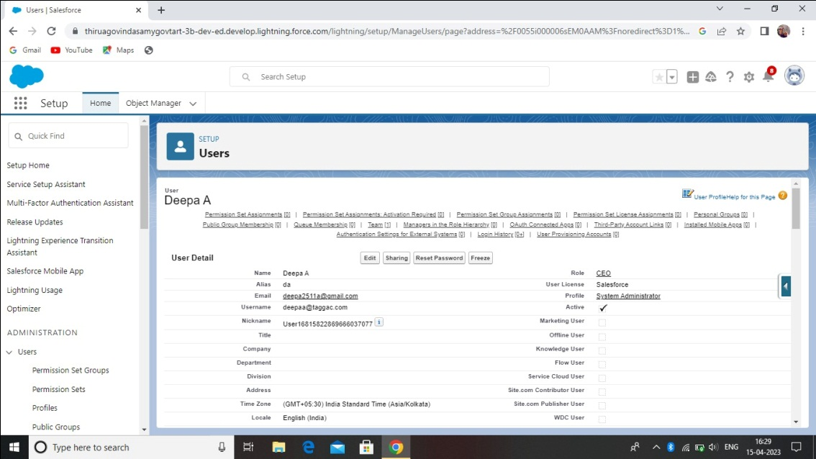

Use Customization

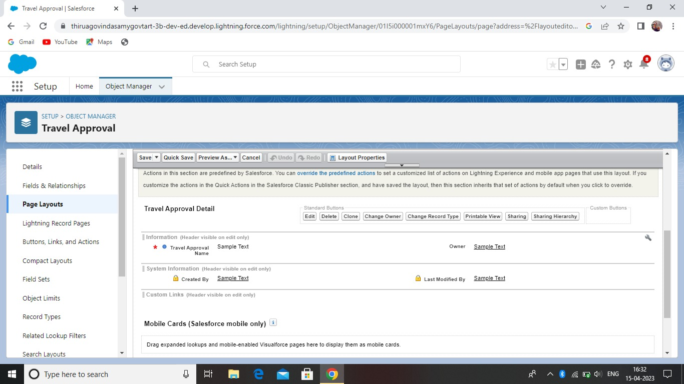

Create Validation Rule

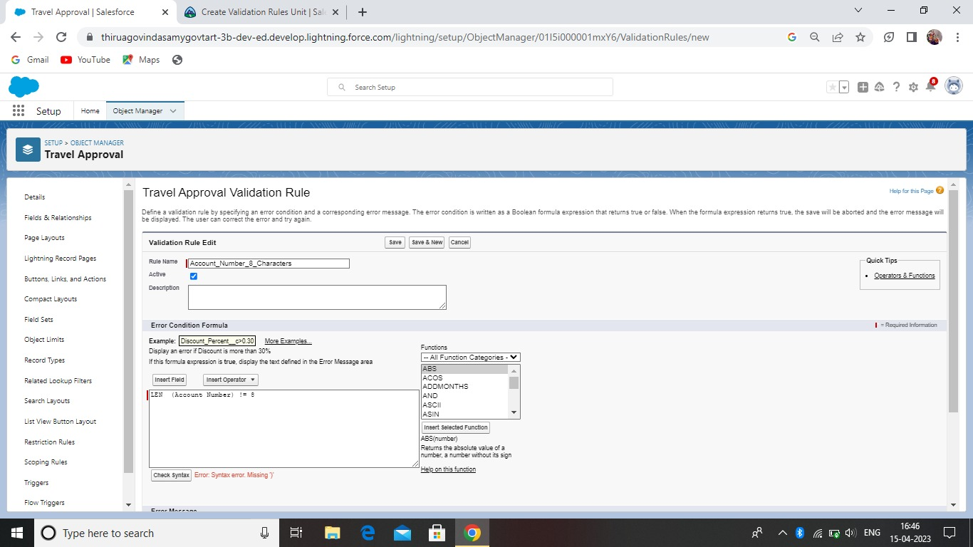

Create Formula Fields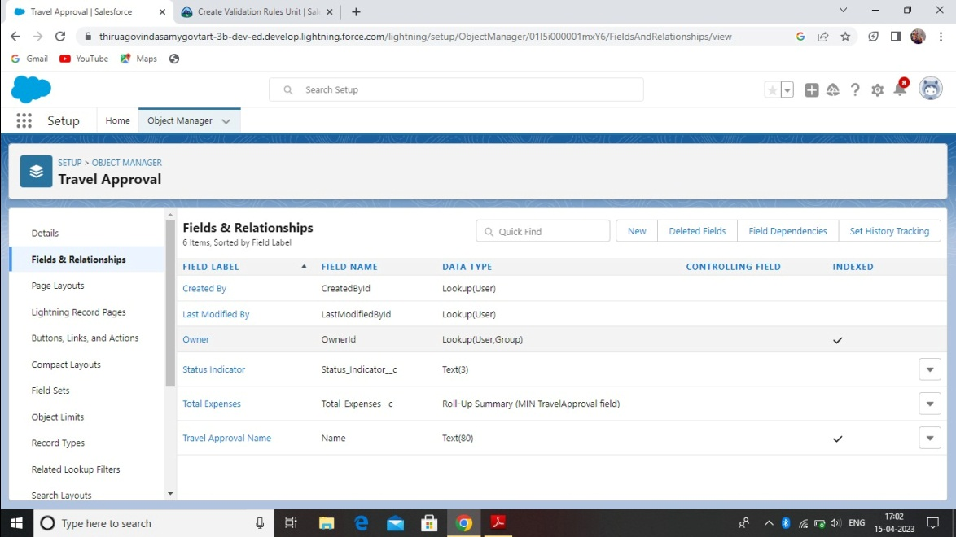

Report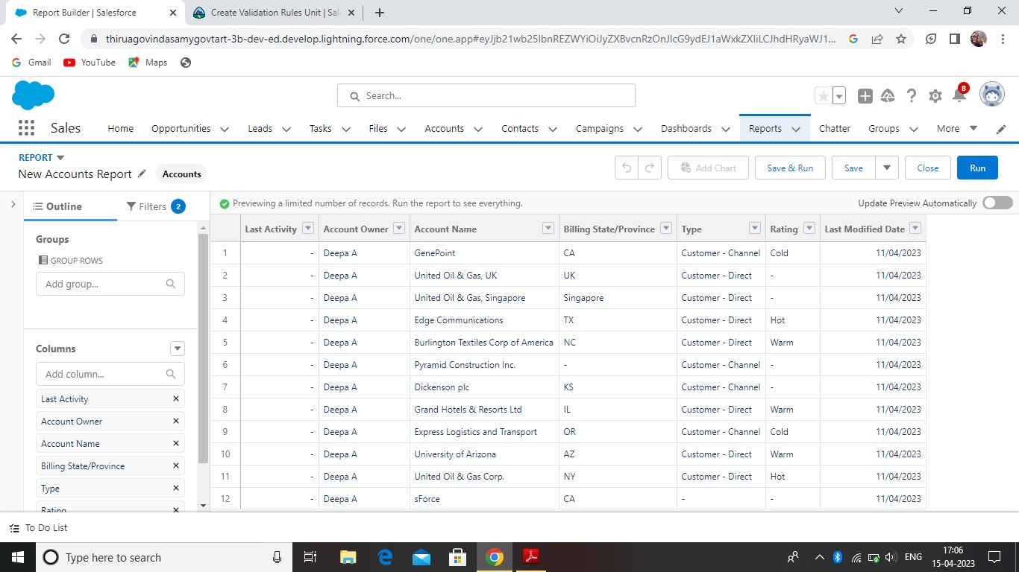

Dashboards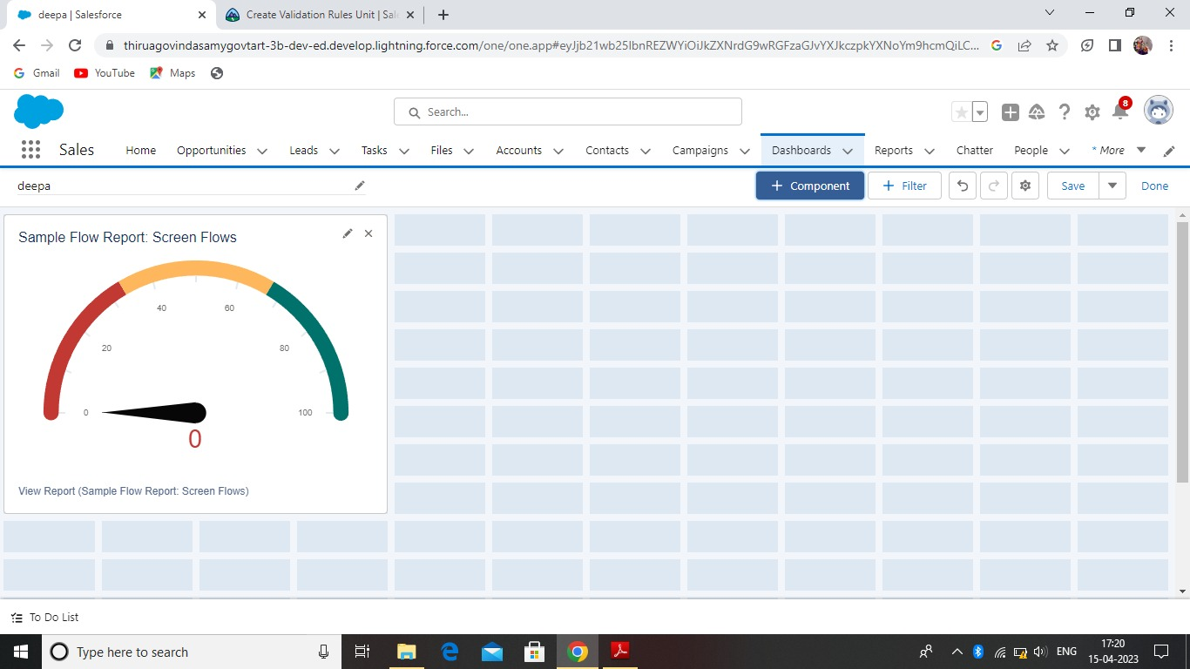

**4. TRAILHEAD PROFILE PUBLIC URL**

Team Lead – https://trailblazer.me/id/deepa1751

Team Member 1 – https://trailblazer.me/id/nmid20922fbdd46944d818a4483ac9ea4a0e

Team Member 2 –https://trailblazer.me/id/kalab15

Team Member 3 –https://trailblazer.me/id/lthilagam

**5. ADVANTAGES**

1. The process is tedious and time consuming task
2. Saves time for both employees and managers
3. Provides greater control and security over employee travel

**DISADVANTAGES**

1. Regular Maintenance
2. Internet Connection problem is there
3. Poor communication
4. Poor connection leads to trouble

**6. APPLICATIONS**

1. Collecting data for marketing
2. Planning your operations
3. Improving interactions and communications

**7. CONCLUSION**

Salesforce is a great platform and easy to use, powerful, quick as well as good community. The project aim is to provide real time knowledge for all the students who have basic knowledge of salesforce and looking for a real time project.

**8. FUTURE SCOPE**

Scope of education means range of view, outlook, field or opportunity of activity, operation and application of education. Education has a wider meaning and application.